Capstone Project on Movie Rental Analysis:

ATHARV V. WAGHMARE

**Project Overview:**

The aim of this project is to create a comprehensive Power BI dashboard using the Sakila DVD Rental Store Database, supplying valuable insights into the rental store business. The analysis will focus on customer behaviour, film inventory management, staff performance, and store operations. The goal is to enable data-driven decision-making and improve overall business performance. The Power BI dashboard will offer insights into customer segmentation, sales trends, film performance, staff productivity, and store revenue.

The primary aim is to perfect film inventory, enhance customer satisfaction, improve staff performance, and streamline store operations. The dashboard will give actionable recommendations for targeted marketing campaigns, film collection enhancements, and staff training initiatives to improve business performance. The final deliverables will include a report and presentation highlighting the dashboard's findings and recommendations. The Power BI dashboard will serve as a valuable tool for rental store owners to make informed decisions and achieve success in the competitive DVD rental market.

In addition to creating a Power BI dashboard, this project also includes a vital phase of Exploratory Data Analysis (EDA). EDA involves the use of SQL queries to extract and examine the dataset for critical insights. SQL queries were employed to address specific problem statements related to customer behaviour, film inventory, staff performance, and store operations. These queries helped uncover patterns, trends, and anomalies in the data.

For Presenting the results of the EDA effectively, visualizations were prepared and organized in an Excel file. These visualizations include charts, graphs, and tables that highlight key findings and patterns. The Excel file serves as a complementary resource to the Power BI dashboard, providing stakeholders with a comprehensive view of the project's insights.

**The Processes:**

**1) Data Acquisition from GitHub:**

It includes collection of data of movie rental analysis from specific github repository, which include data and resources pertinent to rented films of different category along with customer details. After checking data ensured and checking the data is publicly accessible. And downloading the data ensured that the data obtained in formats compatible with chosen analysis tools, such as SQL-Script for database queries and Power BI for visualizations.

**2) Data Transformation:**

Data transformation is a critical step in project that involves shaping and preparing the bought datasets for meaningful analysis. The techniques include data filtering, where I select relevant rows and columns, and data aggregation, which allows us to group and summarize information. I also perform data joining to combine multiple datasets using common keys, and data splitting to divide data into subsets based on specific criteria. Reshaping the data through pivoting or melting helps us change its structure to align with analysis goals. Encoding categorical data into numerical format, scaling numerical values for consistency, and imputing missing data are essential steps to ensure data integrity and relevance. Feature engineering enables us to create new variables that capture meaningful patterns, while parsing dates helps us extract relevant time-based information. These transformations are pivotal in preparing data for the later analysis.

**3) Data Cleaning:**

Data cleaning is an indispensable aspect of data preparation process, aimed at improving data quality and accuracy. In this phase, I address various data anomalies and inconsistencies to ensure the reliability of analysis. Data deduplication removed the data, which helps cut duplicate records that might skew results, while outlier handling names and mitigates outliers that could distort findings. Noise reduction techniques applied to smooth or filter noisy data points that may introduce errors. Data type conversion ensures data types are consistent and suitable for the intended analysis. I also stan whitespace and admit correct case sensitivity issues, trim extraneous whitespace, and perform spell checking to rectify typographical errors. Managing null and zero values, resolving inconsistent data, and rounding numerical data are vital tasks in data cleaning. Redundant or removed irrelevant data, and code mapping assigns meaningful labels to codes. Statistical analysis and linearity assessment help in finding anomalies and patterns.

**4)MECE Breakdown:**

In This project, I adopt a MECE (Mutually Exclusive, Collectively Exhaustive) strategy to ensure a logical and structured progression of data from one phase to the next. This approach serves to organize project components and the seamless dividend of data into next analyses. The project divided into distinct and mutually exclusive phases that focus on specific aspects of the movie rental business. These phases encompass data acquisition, exploratory data analysis (EDA), problem statement resolution through SQL, visualization with Power BI, and next analyses. Each phase has its unique purpose and contributes to the overall project goals without overlapping or duplicating efforts.

**5)Connecting with Tools:**

SQL scripts play a crucial role in project, enabling us to extract and manipulate data directly from a relational database. It supplies seamless connectivity to SQL databases, allowing us to input SQL scripts and query data.

For incorporating CSV data into analysis, I use Power BI's robust data import capabilities. Power BI offers a straightforward and intuitive approach for connecting to CSV files. I access and import CSV data by specifying the file location, ensuring compatibility and consistency with analysis aims. Through this connection, I can easily manipulate, transform, and visualize data directly within Power BI, thus simplifying the data preparation phase.

**6)Exploratory Data Analysis:**

Exploratory Data Analysis (EDA) is an indispensable phase in project. For Begin with the EDA process, I employ SQL queries to tackle specific problem statements. SQL queries offer powerful capabilities for data extraction, transformation, and aggregation, making it a versatile tool for preliminary data analysis. I use SQL to address questions related to customer behaviour, film inventory, staff performance, and store operations. SQL helps us filter, group, and aggregate data to extract relevant information with capability of handling enormous amounts of data. It involves a comprehensive examination of the bought datasets to gain a deeper understanding of the data, find patterns, and extract valuable insights. I use Excel's extensive charting and graphing capabilities to generate informative visualizations, such as bar charts, line graphs, pie charts, and scatter plots. These visualizations supply a clear and concise way to present the outcomes of SQL queries, enabling stakeholders to grasp the insights easily. The combination of SQL for data analysis and Excel for visualization results in a dynamic and interactive approach to EDA.

**6)Power-Bi Analysis:**

Power BI gives a powerful platform for creating interactive and insightful visualizations that transform raw data into meaningful representations. This phase allows us to translate the insights into visually engaging dashboards that address the challenges found during EDA. It involves use of Bar/Columns charts, Pie-charts, Area-charts, Line-charts & matrix-chart for making visualizations along with the insights which are getting by analysing charts. The integration of Power BI visualizations adds a dynamic and interactive dimension to the project. It transforms data give insights & dashboard into actionable recommendations that are readily accessible to stakeholders, store owners, and decision-makers, needed for success.

**7) Documentation:**

Documentation is a cornerstone of project, ensuring that organized work, accessible, and comprehensible to all stakeholders. I have created a comprehensive documentation strategy that includes diverse types of files to capture the various aspects of the project. I have done all documentation of project in a Microsoft Word file which have all information of project.

**Objectives:**

1. **Data Exploration and Understanding:** Projects primary aim is to thoroughly explore and understand the dataset derived from the movie rental industry. I aim to gain insights into the data's structure, relationships, and potential areas for analysis.
2. **Customer Segmentation and Profiling:** I intend to segment customers based on their rental behaviours, preferences, and demographics. By creating customer profiles, I offer targeted marketing strategies and personalized recommendations.
3. **Film Performance Analysis:** This project looks to analyse the performance of films within the rental store. This includes finding top-performing films, assessing their popularity, and recommending strategies for buying or promoting films to perfect revenue.
4. **Staff Productivity Assessment:** An important aim is to assess the productivity and performance of staff members. I aim to find high-performing employees, pinpoint areas for improvement, and recommend staff training or incentive programs.
5. **Store Operations Efficiency:** The project strives to enhance the overall efficiency of store operations. By analysing operational data, I find bottlenecks, streamline processes, and improve store revenue while keeping or reducing costs.
6. **Data Visualization and Storytelling:** I aim to create informative and engaging data visualizations using Power BI to effectively communicate my findings. These visualizations should tell a compelling data-driven story that is easy for stakeholders to understand.
7. **Informed Decision-Making**: My overarching aim is to provide rental store owners and decision-makers with the insights and recommendations needed to make informed decisions. I want to empower them with the tools to drive success in the competitive movie rental market.

These revised aims should supply a clearer focus on data exploration, customer segmentation, film performance analysis, staff productivity, store operations, and effective communication of findings. They are well-aligned with the dataset and the goals of movie rental analysis project.

**Significance:**

1. **Data-Driven Decision-Making:** In an era where data plays a vital role in shaping business strategies, this project empowers rental store owners and stakeholders with the tools and insights needed for data-driven decision-making. By analysing customer behaviour, perfecting film inventory, enhancing staff performance, and streamlining store operations, this project enables informed choices that have a direct impact on business success.
2. **Customer-Centric Approach:** Understanding customer behaviour is at the heart of the project's significance. By segmenting customers, personalizing marketing strategies, and improving customer satisfaction, contribute to a customer-centric approach that can enhance loyalty and drive revenue growth.
3. **Efficiency and Cost Reduction:** This project addresses the need for efficiency and cost reduction by perfecting film inventory and store operations. By finding top-performing films, streamlining operational processes, and reducing unnecessary costs, contribute to improved profitability and sustainability for rental stores.
4. **Competitive Advantage:** In a highly competitive market, the project provides rental store owners with a competitive advantage. Through data insights, recommended marketing strategies, and staff performance enhancements, project equips businesses with the means to outperform competitors and excel in the industry.
5. **Data Quality and Reliability:** Ensuring data quality and reliability is paramount in project. By performing data cleaning and validation, I not only improve the quality of the analysis but also set a standard for the integrity of data in the industry. This has far-reaching implications for other businesses and data-driven ventures.
6. **Transparency and Reproducibility:** This project embraces transparency and reproducibility by documenting the entire process and methods. This approach sets a precedent for projects in various domains, emphasizing the importance of open and transparent data analysis practices.
7. **Knowledge Transfer and Education:** The insights and recommendations generated by project serve as valuable educational resources. They can use to educate stakeholders, staff, and the wider industry on the benefits of data analysis and data-driven decision-making.
8. **Stakeholder Empowerment:** This project aims to empower stakeholders, rental store owners, and decision-makers with the knowledge and tools needed to succeed in the movie rental market. It serves as a catalyst for positive change and business growth. The significance of this project extends beyond the movie rental industry, highlighting the transformative power of data analysis, customer-centric strategies, and operational efficiency in any business context.

**Data Dictionary:**

Dataset is a comprehensive collection of information from a movie rental service, encompassing a wide array of tables with details on actors, films, customers, rental transactions, & more. This rich dataset forms the foundation of my analysis, supplying insights into customer behaviour, film inventory management, & operations.

**Table Explanations:**

**Actor Table:** The actor table lists information for all the actors.

* Actor id (Primary Key): A unique identifier for each actor.
* first name: The first name of the actor.
* last name: The last name of the actor.

**Address Table:** The address table has address information for customers, staff.

* Address id (Primary Key): A unique identifier for each address.
* address: The street address.
* address2: Additional address information, if available.
* district: The district or area.
* City id (Foreign Key): A reference to the city table, standing for the city where the address is present.
* Postal code: The postal code.
* phone: The phone number associated with the address.

**Category Table:** The category table lists the categories that can assigned to films.

* Category id (Primary Key): A unique identifier for each category.
* name: The name of the category.

**City Table:** The city table holds a list of cities.

* City id (Primary Key): A unique identifier for each city.
* city: The name of the city.
* Country id (Foreign Key): A reference to the Country table, standing for the country or region where the city is present.

**Country Table:** The country table holds a list of countries or regions.

* Country id (Primary Key): A unique identifier for each country.
* country: The name of the country or region.

**Customer Table**: The customer table holds a list of all customers.

* Customer id (Primary Key): A unique identifier for each customer.
* Store id (Foreign Key): A reference to the Store table, showing the store where the customer registered.
* First name: The first name of the customer.
* last name: The last name of the customer.
* email: The customer's email address.
* Address id (Foreign Key): A reference to the Address table, specifying the customer's address.
* active: A flag showing whether the customer's account is active.
* Create date: The date when the customers created account.

**Film Table:** The film table lists all the films that may be in stock in the store.

* Film id (Primary Key): A unique identifier for each film.
* title: The title of the film.
* description: A brief description of the film.
* Release year: The year when the film released.
* Language id (Foreign Key): A reference to the Language table, specifying the film's language.
* Original language id (Foreign Key): A reference to the Language table, standing for the original language of the film.
* Rental duration: The rental duration of the film.
* Rental rate: The rental rate for the film.
* Replacement cost: The cost to replace the film.
* rating: The film's content rating.

**Film text Table:** The content of the film text table kept in synchrony with the film table by triggers on the film table INSERT, UPDATE, and DELETE operations.

* Film id (Foreign Key): A reference to the Film table, with film title.
* film title: The title of the film.
* description: A brief description of the film.

**Film actor Table:** The film actor table support many to many relationships’ films and actors.

* Actor id (Foreign Key): A reference to the Actor table, stands for the actor associated with the film.
* Film id (Foreign Key): A reference to the Film table, showing the film in which, the actor appeared.

**Film category Table:** The film category table support many to many relationships between films and categories.

* Film id (Foreign Key): A reference to the Film table, specifying the film associated with a category.
* Category id (Foreign Key): A reference to the Category table, showing the category assigned to the film.

**Inventory Table:** The inventory table is a copy of a given film in each store.

* Inventory id (Primary Key): A unique identifier for each inventory item.
* Film id (Foreign Key): A reference to the Film table, stands for the film in the inventory.
* Store id (Foreign Key): A reference to the Store table, showing the store where the inventory item is.
* last update: The date and time when the inventory item updated.

**Language Table:** The table lists all values for the film & original language.

* Language id (Primary Key): A unique identifier for each language.
* name: The name of the language.

**Payment Table**: The payment table records every payment made by the customer, including information such as the amount and rent paid.

* Payment id (Primary Key): A unique identifier for each payment transaction.
* Customer id (Foreign Key): A reference to the Customer table, specifying the customer who made the payment.
* Staff id (Foreign Key): A reference to the Staff table, showing the staff member who processed the payment.
* Rental id (Foreign Key): A reference to the Rental table, standing for the rental associated with the payment.
* amount: The payment amount.
* Payment date: The date and time when of the payment.

**Rental Table:** The rental table holds a row for each rental of each inventory item, which holds information about who rented what, when it rented it, and when it returned.

* Rental id (Primary Key): A unique identifier for each rental transaction.
* Rental date: The date and time when the movie rented.
* Inventory id (Foreign Key): A reference to the Inventory table, showing the inventory item rented.
* Customer id (Foreign Key): A reference to the Customer table, specifying the customer who rented the film.
* Return date: The date and time when the rental returned.
* Staff id (Foreign Key): A reference to the Staff table, standing for the staff member who processed the rental.

**Staff Table:** The staff table lists all staff information, including email addresses, login information, and pictures.

* Staff id (Primary Key): A unique identifier for each staff member.
* first name: The first name of the staff member.
* last name: The last name of the staff member.
* Address id (Foreign Key): A reference to the Address table, specifying the staff member's address.
* email: The email address of the staff member.
* Store id (Foreign Key): A reference to the Store table, showing the store where the staff member works.
* active: A flag showing whether the staff member is currently active.
* username: The staff member's username for system login.
* password: The staff member's password for system login.
* last update: The date and time of the staff member's last update.

**Store Table:** The store table lists all stores in the system.

* Store id (Primary Key): A unique identifier for each store.
* Manager staff id (Foreign Key): A reference to the Staff table, standing for the staff member who manages the store.
* Address id (Foreign Key): A reference to the Address table, specifying the store's address.

**Entity Relationship (ER) Diagram:**

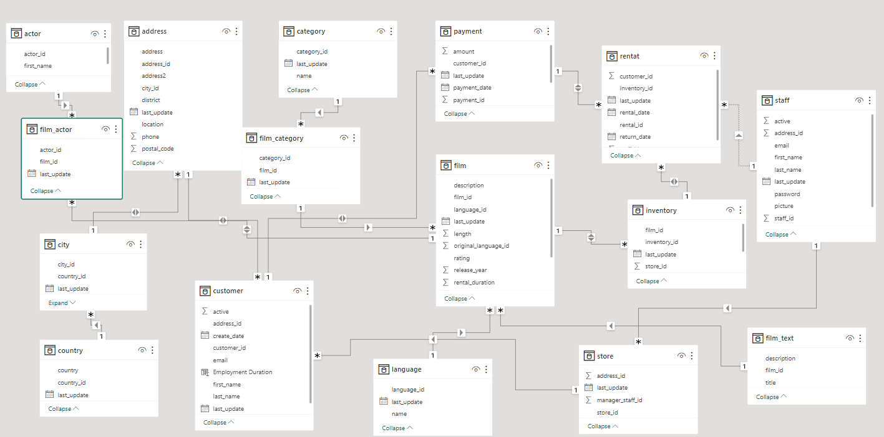

**MECE Breakdown**

**Customer Analysis:**

* Demographics: Categorize customers by gender, location(city/country).
* Language: Customers mostly prefer which language movies.
* Status: Identify number of Active or Inactive customer.

**Rental Analysis:**

* Rental Trends: Examine Rental duration & returning times of customers.
* How often film rented: Examine how often individual customers rent films.
* Rental Returned: Track the return dates of rentals, to check if they are late.

**Revenue Analysis:**

* Revenue Trends: Examine Revenue variation by countries & by Film Categories.
* Revenue: Examine Revenue by Rental Duration.
* Distribution: Inventory wise Revenue Distribution.

**Film Analysis:**

* Film Popularity: Find most & least rented films.
* Rating Analysis: Find how film ratings relate to rentals.
* Special Feature: Find which specific features mostly use in films.
* Film Length: Study customer viewing habits and rental choices related to film length.

**Location Analysis:**

* Revenue: Analyse Country wise Revenue.
* Rating: Country wise Rental Rate & Rental Duration.
* Distribution: Customer Distribution by Country.

**Actor Analysis:**

* Appearance: Identify actors who appear in the most-rented films.
* Performance: Which actor has a greater number of popular films & contributing more Revenue.
* Variation: Actor wise Rental Rate Variation.

**Exploratory Data Analysis:**

**Problem Statement:**

1) What are the purchasing patterns of new customers versus repeat customers?

**SQL-Query:**

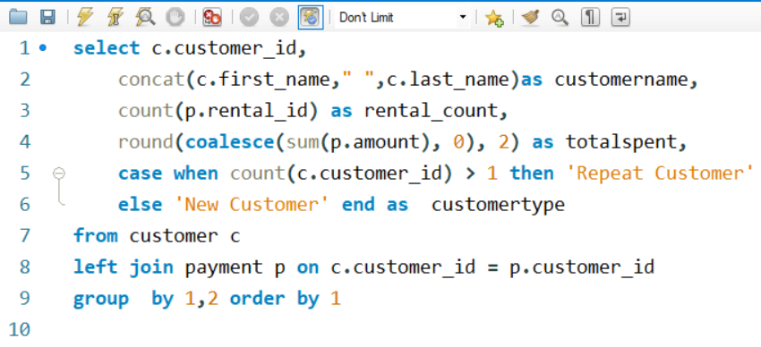

**Insights:**

The line chart depicting the purchasing patterns of new customers versus repeat customers provides essential insights into customer behavior and highlights significant opportunities for the rental store's marketing and engagement strategies. The chart clearly illustrates that a portion of new customers has not yet made any purchases. This finding is crucial as it indicates a potential gap in the onboarding process or customer engagement.

It's essential to recognize that the portion of new customers not making purchases represents untapped potential. This untapped customer segment can be a goldmine if approached strategically. Targeted marketing efforts, such as welcome discounts or personalized recommendations, can be devised to convert these prospects into paying customers, thereby increasing revenue.

Moreover, tracking the progression of customers with no purchases is vital for measuring the effectiveness of onboarding and engagement strategies. It allows the rental store to identify where in the customer journey these individuals drop off or disengage, facilitating a more informed and data-driven approach to improve customer retention and satisfaction.

By understanding these patterns and taking corrective actions, the rental store can enhance the overall customer experience and potentially increase customer lifetime value, ultimately contributing to its success in the competitive movie rental market.

**Problem Statement**:

2) Which films have the highest rental-rates and are most in demand?

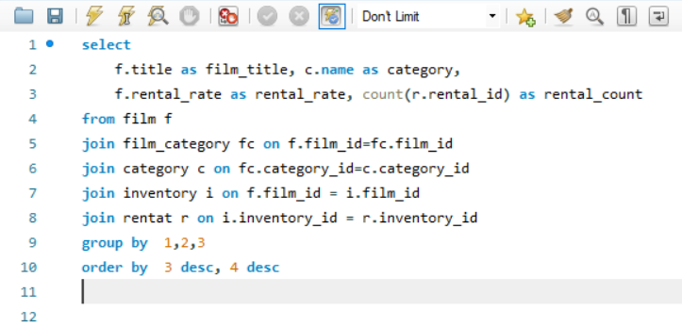**SQL-Query:**

**Visualization:**

**Insights:**

The chart vividly illustrates a compelling trend – films with higher rental rates tend to be in high demand. This correlation signifies that customers are not only willing to pay more for films but are also actively seeking out movies that they find highly appealing and entertaining. As a prime example, the movie "BUCKET BROTHERHOOD" exhibits both higher rental rates and remarkable demand, highlighting its strong desirability among viewers.

This observation is of paramount significance for rental stores. By analysing films with the highest rental rates and demand, rental businesses can strategically prioritize their inventory and marketing endeavours. This entails ensuring that popular titles, particularly those that combine affordability with high demand, are readily available to cater to customer preferences.

Maximize revenue, rental stores can consider promoting films that strike this balance between high rental rates and high demand. Such films are not only likely to generate substantial income but also reflect customer preferences. Implementing this strategy can prove to be a revenue booster, aligning inventory with customer expectations and driving profitability.

The chart underscores the powerful interplay between rental rates, customer demand, and film popularity. It emphasizes the importance of data-informed inventory management and marketing strategies for rental stores. By aligning their offerings with customer preferences, rental stores can enhance customer satisfaction and revenue, thriving in the competitive movie rental market.

**Problem Statement:**

3)Examine Rental duration & returning times of customers.

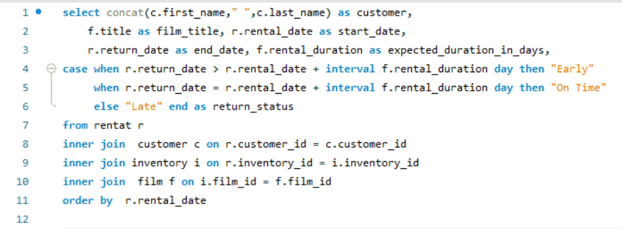**SQL-Query:**

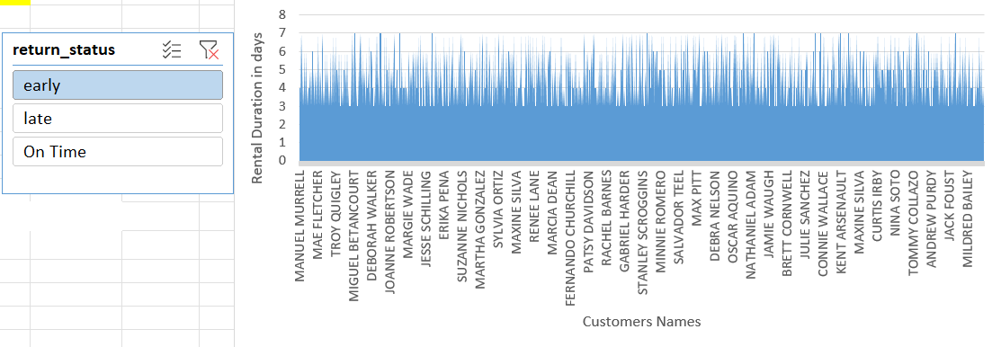**Visualization:**

**Insights:**

The area chart gives a nuanced view of the rental duration distribution, notably featuring early returns, and late returns. A generous part of customers returns films within the expected 3 to 7-day duration, adhering to the store's guidelines.

However, the chart also highlights that a considerable number of customers show early return behaviour, showing a preference for prompt film returns. Simultaneously, there are instances of late returns, suggesting customers might receive help from late return policies or incentives for early returns to streamline their movie rental experience.

Analysing this customer rental behaviour is not only useful for managing inventory more effectively but also for making data-driven decisions. The rental store can use this data to strike a balance between customer convenience and operational efficiency, enhancing customer satisfaction and store performance.

This insight-driven approach empowers the rental store to refine its rental policies and customer engagement strategies, aiming for a best and harmonious movie rental experience.

**Problem Statement:**

4)Are there seasonal trends in customer behaviour across distinct locations?

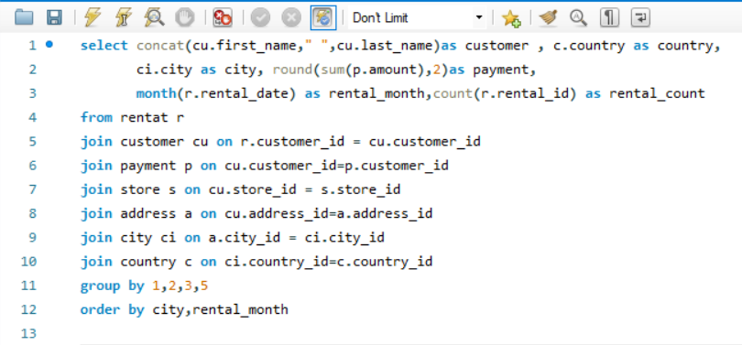**SQL-Query:**

**Visualization:**

**Insights:**

The analysis of seasonal trends in customer behavior across diverse locations unveils a captivating narrative - specific film categories witness a surge in demand during distinct seasons. This chart elegantly illustrates these fluctuations, with an unmistakable pattern emerging. Notably, more customers engage in film-watching activities during the sixth month (July) and the eighth month (October), marking these periods as peak seasons for movie rentals. Conversely, customer engagement tends to wane during the second month (February), signaling lower viewership.

These seasonal variations present a significant opportunity for rental stores to fine-tune their inventory management strategies. By aligning their film offerings with the ebb and flow of customer preferences, rental businesses can ensure they stock the right films to cater to the heightened demand during peak seasons. This strategic approach isn't just about increasing customer satisfaction; it's also a revenue optimization tactic that can significantly impact the bottom line.

Furthermore, by tracking customer preferences over the seasons, rental stores can craft targeted marketing campaigns and promotions that capitalize on these well-defined trends. This proactive approach can attract more customers during peak seasons, offering tailored experiences and incentives that further elevate customer engagement and drive rental revenue to new heights.

In essence, this chart showcasing seasonal trends in customer behavior represents an invaluable tool for rental stores seeking to enhance their operations. It highlights the potential for strategic inventory management and targeted marketing efforts that cater to customer desires throughout the year, ultimately positioning rental businesses for success in a dynamic and competitive movie rental market.

**Problem Statement:**

5)How replacement costs affect the financial aspects of rental store?

**SQL-Query:**

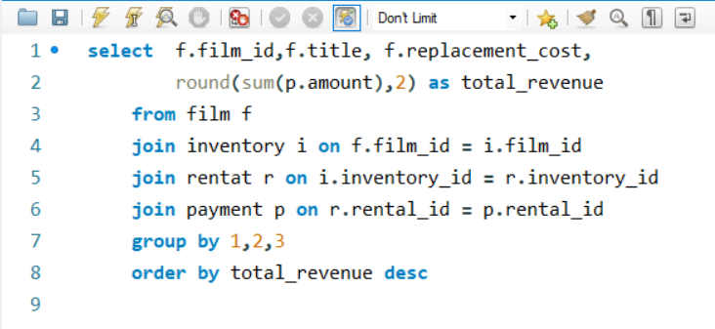

**Visualization:**

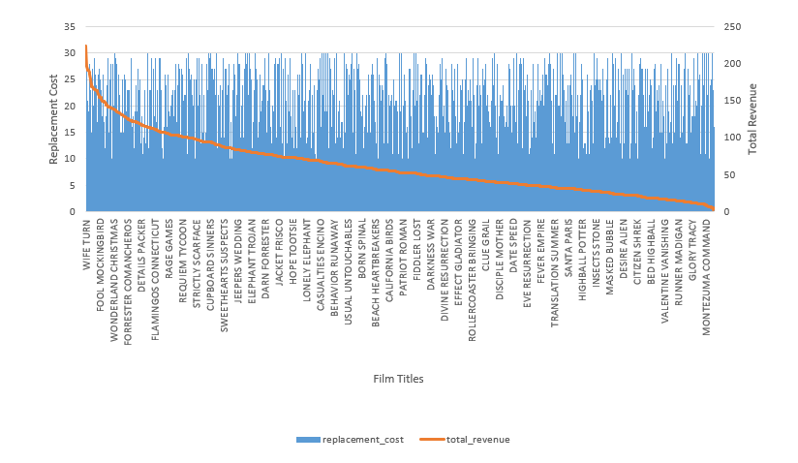

**Insights:**

The chart before us presents a revealing narrative about the interplay between replacement costs and film revenue. Notably, the film "WIFE TURN" stands out with the highest replacement cost and, intriguingly, it generates the highest revenue. This observation underscores the direct impact of replacement costs on the profitability of the rental store. Higher replacement costs are a critical factor in the financial equation, particularly when films are often damaged or lost by customers.

For keeping financial stability, the rental store faces the essential task of striking a delicate balance. It involves offering a diverse film selection to meet customer preferences while simultaneously managing replacement costs effectively. Achieving this balance needs vigilant monitoring of damage rates, setting proper replacement fees that neither deter customers nor lead to losses, and implementing preventive measures to curtail film losses.

For mitigating the budgetary impact of replacement costs, rental stores can implement strategic measures. Customer education on responsible film handling is an initiative-taking step, fostering greater care among customers and reducing accidental damage or loss. Efficient inventory tracking systems are equally instrumental, as they aid in the prompt identification of missing or damaged films, allowing for prompt action and cost control.

In summary, this chart illustrates the intricate relationship between replacement costs and rental store revenue. It emphasizes the financial implications of replacement fees on the rental business's financial health and profitability. By adopting a strategic approach that encompasses customer education, fee management, and preventive measures, rental stores can navigate this challenge effectively, ensuring their long-term financial stability and success in the competitive movie rental industry.

**Problem Statement:**

6)How customer loyalty impact sales revenue over time?

**SQL-Query:**

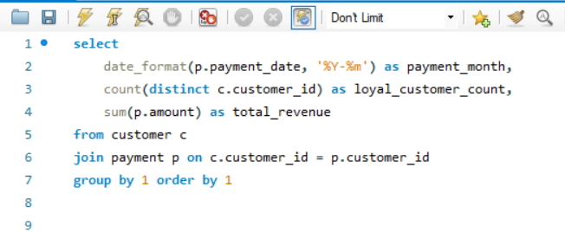

**Visualization:**

|  |  |  |
| --- | --- | --- |
| **payment month** | **Loyal customer count** | **total revenue** |
| 2005-05 | 455 | 4239.83 |
| 2005-06 | 512 | 8438.63 |
| 2005-07 | 521 | 24618.63 |
| 2005-08 | 520 | 21092.2 |
| 2006-02 | 134 | 442.44 |

**Insights:**

The provided output paints a vivid picture of the correlation between customer loyalty and revenue growth over time. Notably, the seventh (2005-07) and eighth (2005-08) months appear as peak periods, boasting the highest count of loyal customers and generating substantial revenue. This observation underscores the pivotal role that customer loyalty plays in the financial trajectory of the rental store.

Customer loyalty is not merely a fleeting attribute but a significant driver of long-term revenue generation. Loyal customers form the backbone of a successful rental business, consistently making more frequent and higher-value transactions over time. Their sustained engagement and repeated patronage contribute significantly to the store's sustainable financial success.

The data underscores the importance of nurturing and keeping loyal customers as a strategic imperative for rental stores. By offering exceptional customer experiences, personalized recommendations, and rewards for loyalty, rental businesses can further solidify their customer base and keep a steady revenue stream. Furthermore, the identification of peak months in terms of loyal customer count and revenue generation supplies valuable insights into when to focus marketing efforts and loyalty initiatives for best impact.

In summary, this data illuminates the symbiotic relationship between customer loyalty and revenue growth. It highlights the pivotal role of loyal customers in ensuring the long-term financial health and success of the rental store. By fostering and capitalizing on customer loyalty, rental businesses can secure their competitive edge in the movie rental industry and continue to thrive in an ever-evolving market.

**Problem Statement:**

7) Are certain film categories more popular in specific locations?

**SQL-Query:**

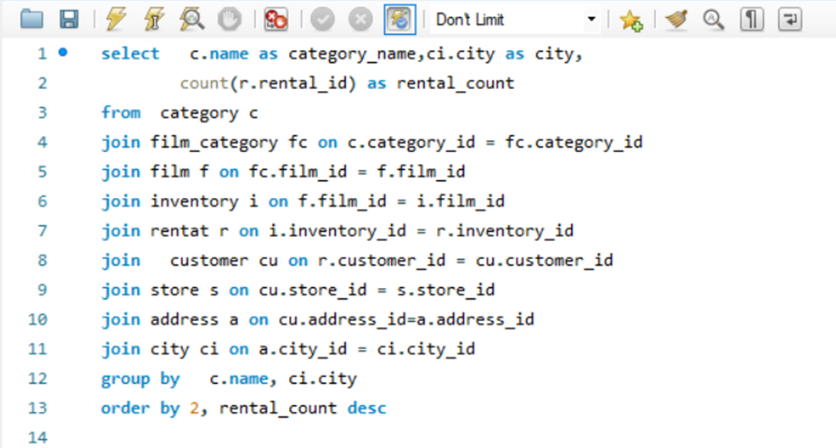

**Visualization:** 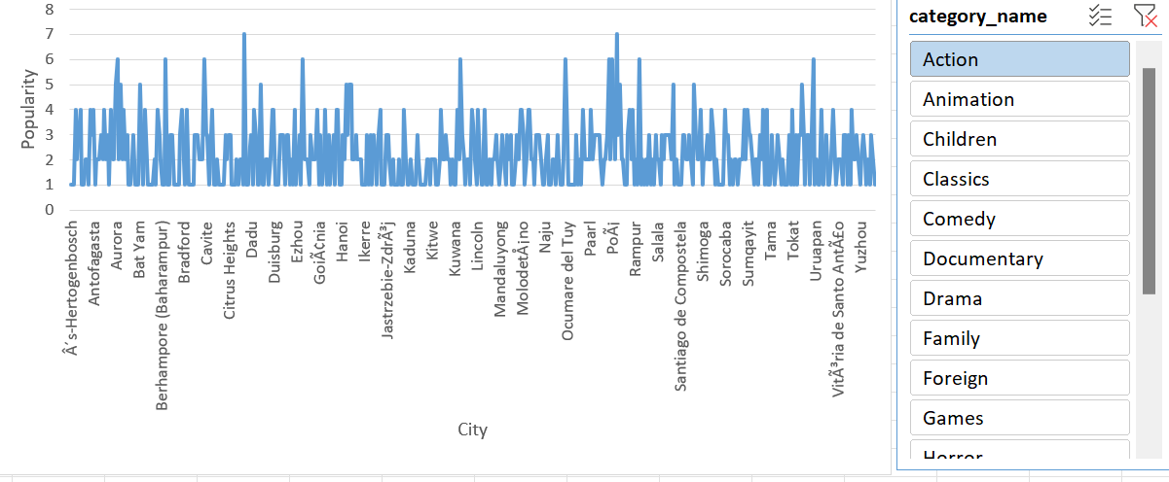

**Insights:**

The chart effectively illustrates the fascinating phenomenon of varying film category preferences across distinct locations. Notably, that “Action” and “Sport” categories stand out as the most popular film categories in the depicted locations. This observation underlines the significance of understanding the nuanced film tastes of diverse customer bases.

The data chart contributes to a deeper comprehension of the intricacies of film category popularity within distinct regions. This insight, in turn, opens avenues for rental stores to adopt more targeted marketing and inventory management strategies. By acknowledging the preferences of specific locations, rental businesses can curate their offerings to align with local tastes. This strategic approach has the potential to elevate customer satisfaction and, after, enhance overall rental revenue.

The chart is a valuable tool for rental stores looking to tailor their services to the diverse demands of their customer base. Recognizing the unique popularity of film categories in various locations empowers rental businesses to craft a more personalized and customer-centric approach, solidifying their position in the competitive movie rental market.

**Problem Statement:**

8) Identify actors who appear in the most-rented films.

**SQL-Query:**

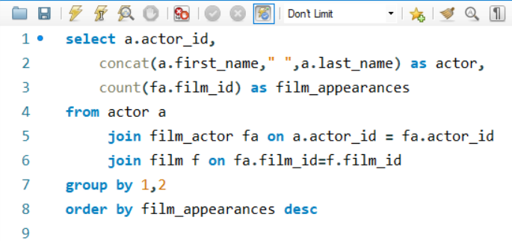

**Visualization:**

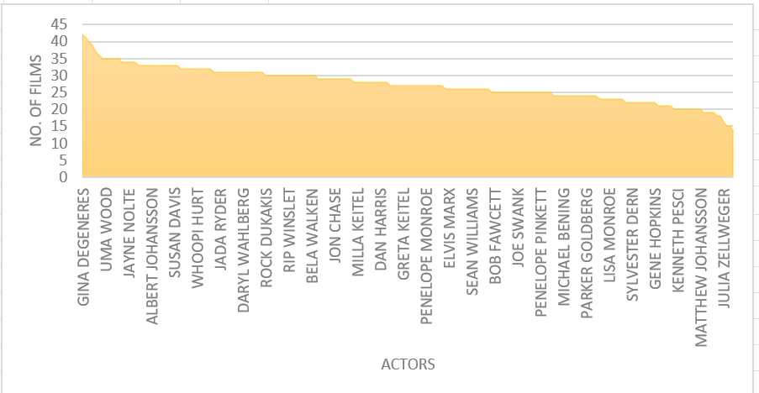

**Insights:**

The area chart supplies a comprehensive view of actors who consistently appear in the most-rented films, shedding light on their enduring popularity among audiences and their significant impact on the success of film rentals. Notably, "GINA DEGENERES" stands out as the actor with the highest number of film appearances, illustrating their strong and lasting presence in the movie rental industry.

This chart serves as a valuable tool for understanding the dynamic relationship between certain actors and the rental success of movies. It underscores the pivotal role of casting decisions in the film industry. Actors who often feature in the most-rented films hold considerable influence in drawing audiences, contributing to the commercial success of movies. It emphasizes that casting choices are not merely artistic decisions but strategic ones that significantly affect the bottom line.

Moreover, the insights derived from this chart can guide film production companies in making informed casting choices. Finding actors in high demand for rentals offers a data-driven approach to perfect the commercial success of their projects. Producers and casting directors can use this information to align their choices with the preferences of rental audiences, potentially leading to higher box office returns and overall profitability.

In summary, the chart's portrayal of actors with the most-rented films is a testament to the enduring impact of talent on film rentals. It emphasizes the necessity of data-backed casting decisions and offers a pathway for the film industry to harness audience preferences, enhance movie rental success, and make more profitable films.

**Problem Statement:**

9)How does the proximity of stores to customers affect rental frequency?

**SQL-Query:**

**Visualization:**

**Insights:**

The analysis of store proximity to customers unveils a compelling narrative of its influence on rental frequency. As depicted in the data, customers tend to engage more often in rentals when they have convenient access to nearby rental stores. This close spatial relationship between stores and customers results in a higher rental frequency, as customers are more inclined to visit and rent movies when stores are within easy reach.

The implications of this insight are profound for rental store operations. It underscores the pivotal role of store location in deciding customer engagement. By strategically placing rental stores near residential areas or high-traffic zones, rental businesses can capitalize on this trend to boost rental frequency and customer loyalty.

Moreover, understanding the interplay between store proximity and rental frequency can inform expansion and growth strategies. Rental stores can use this data to find underserved areas where the establishment of new stores may lead to increased rental frequency and revenue. Conversely, it may also highlight areas where consolidation or store closures might consider too perfect resources and profitability.

In summary, the data emphasizes the tangible impact of store proximity on rental frequency. It underscores the importance of location as a strategic advantage for rental businesses, offering a pathway to enhanced customer engagement and financial success. This insight enables rental stores to align their expansion and store management strategies with the goal of supplying convenient and accessible rental services to their customers.

**Problem Statement:**

10) Do specific film categories attract different age groups of customers?

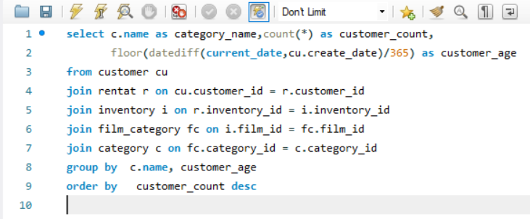**SQL-Query:**

**Visualization:**

|  |  |  |
| --- | --- | --- |
| **category name** | **customer count** | **customer age** |
| Sports | 1179 | 17 |
| Animation | 1166 | 17 |
| Action | 1112 | 17 |
| Sci-Fi | 1101 | 17 |
| Family | 1096 | 17 |
| Drama | 1060 | 17 |
| Documentary | 1050 | 17 |
| Foreign | 1033 | 17 |
| Games | 969 | 17 |
| Children | 945 | 17 |
| Comedy | 941 | 17 |
| New | 940 | 17 |
| Classics | 939 | 17 |
| Horror | 846 | 17 |
| Travel | 837 | 17 |
| Music | 830 | 17 |

**Insights:**

The query results reveal an intriguing correlation between specific film categories and the age group of customers. Notably, the category "Sports" attracts the highest number of customers in the age group of seventeen, closely followed by "Animation" and "Action" categories.

This data suggests that certain film categories hold a strong appeal for younger audiences, particularly those aged seventeen. Understanding this age-based preference can guide marketing strategies, content choice, and customer engagement initiatives. It implies that targeting promotions, recommendations, or dedicated events related to these film categories can be highly effective in attracting and keeping customers within this age group.

Conversely, the lower customer count for certain categories among customers aged 17 may show potential areas for growth. By tailoring offerings to diverse age groups, the rental store can perfect its market presence and cater to a broader spectrum of customer preferences.

In summary, this data highlights the interplay between film categories and customer age groups, supplying a foundation for strategic decisions that can enhance customer engagement and drive revenue growth. It underscores the importance of a data-driven approach in aligning the store's offerings with the preferences of distinct customer segments.

Top of Form

**Problem Statement:**

11)What are the demographics and preferences of the highest-spending customers?

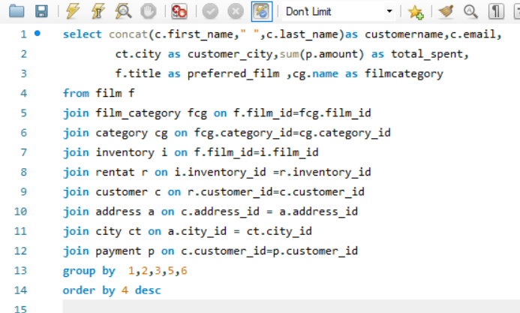**SQL-Query:**

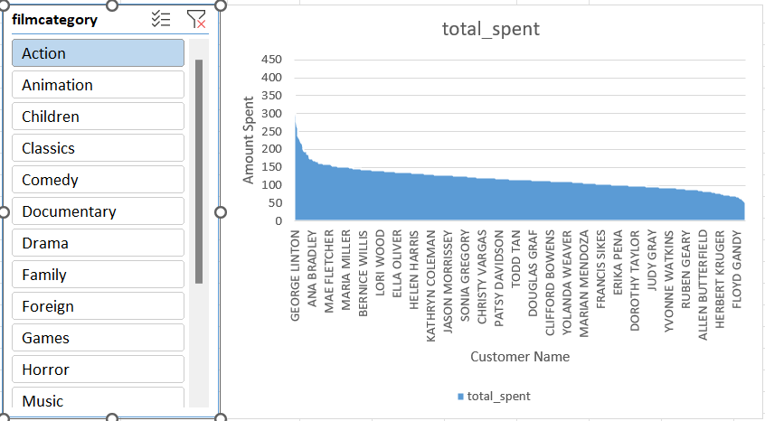**Visualization:**

**Insights:**

The area chart offers a comprehensive view of the highest-spending customers' demographics and film preferences. Notably, it reveals that customers in the age group of 30-40 are the highest spenders, showing the potential for targeted marketing efforts to keep and attract customers within this age range.

Moreover, it becomes clear that these high-spending customers show a preference for film categories such as "Action," "Drama," and "Comedy." Understanding these preferences is essential for perfecting inventory choice and tailoring recommendations to enhance the customer experience.

This data underscores the importance of data-driven strategies for customer engagement. By analysing the demographics and preferences of high-spending customers, the rental store can design promotions, recommendations, and loyalty programs that resonate with this specific group, driving revenue growth.

Furthermore, this information supplies insights into the unique behaviour of high-spending customers, offering opportunities to enhance their experience by offering personalized incentives, exclusive film selections, and improved customer service.

In summary, this data empowers the rental store to create a tailored approach for its highest-spending customers, capitalizing on their preferences and demographics to drive increased customer satisfaction and long-term loyalty. It is a pivotal step in perfecting revenue and achieving success in the competitive movie rental market.

**Problem Statement:**

12) How does the availability of inventory impact customer satisfaction and repeat business?

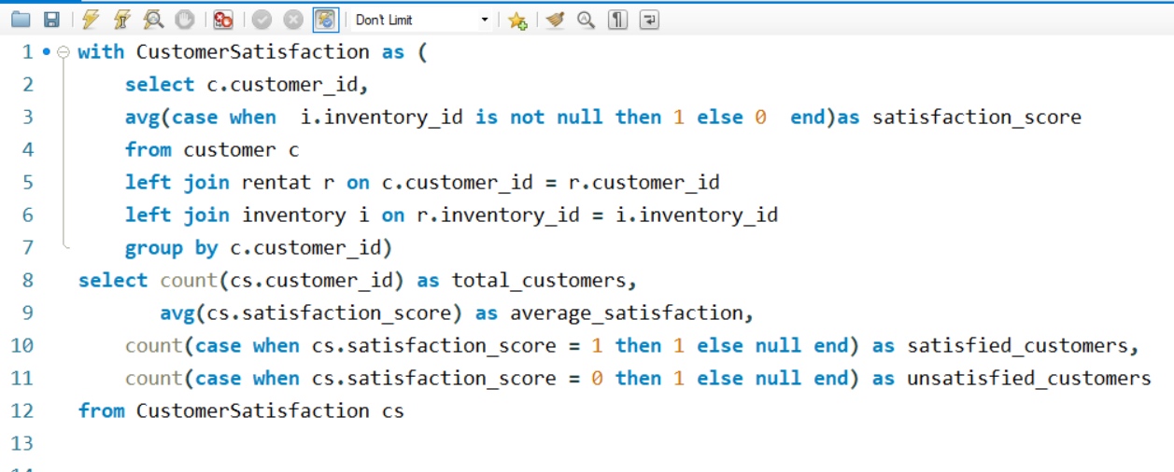**SQL-Query:**

**Visualization:**

|  |  |  |  |
| --- | --- | --- | --- |
| **total customers** | **average satisfaction** | **satisfied customers** | **unsatisfied customers** |
| 599 | 1 | 599 | 0 |

**Insights:**

The data highlights a remarkable 100% customer satisfaction rate among 599 total customers, as showed by an average satisfaction rating of one. This signifies a strong connection between inventory availability and customer satisfaction, where all customers express prominent levels of contentment.

The absence of unsatisfied customers in this dataset underscores the positive impact of having a well-stocked inventory. It suggests that the rental store effectively meets customer demands, resulting in a positive movie rental experience.

This data reaffirms that inventory availability significantly influences customer satisfaction, which, in turn, fosters repeat business. Maintaining a diverse and readily available inventory is crucial for ensuring customer contentment and driving long-term success in the movie rental industry.

**Problem Statement**:

13) What are the busiest hours or days for each store location, and how does it affect staffing requirements?

**SQL-Query:**

**Visualization:**

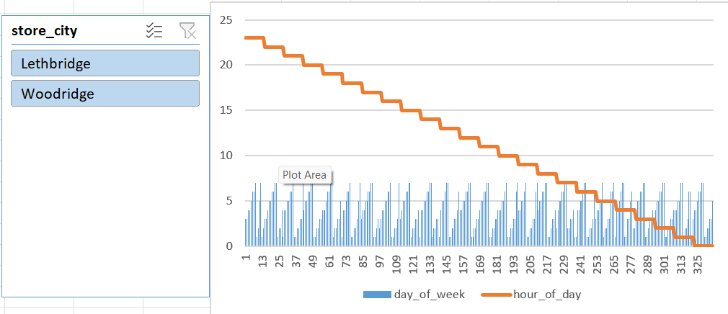

**Insights:**

This chart supplies a visual representation of the busiest hours and days for each store location, highlighting distinct patterns between the two stores, Woodridge, and Lethbridge. Analysing these patterns allows for better staffing allocation based on the unique needs of each location. For instance, while Woodridge may experience higher customer traffic during specific days and hours, Lethbridge may have a distinct set of peak times.

By tailoring staffing requirements to match these variations, rental stores can perfect customer service, ensuring adequate support during the busiest working days and hours, enhancing customer satisfaction and operational efficiency. Additionally, data-driven insights enable stores to plan recruitment strategies and distribute resources effectively to meet customer demand.

**Problem Statement:**

14) Study customer viewing habits and rental choices related to film length.

**SQL-Query:**

:

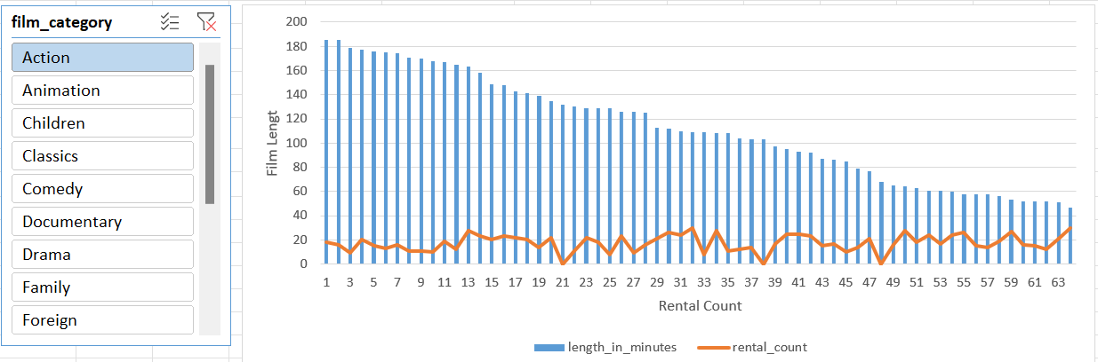**Visualization:**

**Insights:**

The chart offers a comprehensive understanding of customer preferences about film length. Notably, it reveals a pronounced inclination towards films with durations in the range of 0-100 minutes, which corresponds to a significant spike in rentals. This data is invaluable for rental stores as it sheds light on customer behaviour and preferences.

The strong preference for shorter films within this duration range is indicative of a customer base seeking convenience and efficient viewing experiences. These films align with their schedules and preferences, reflecting a desire for shorter, engaging content.

Understanding these viewing habits is pivotal for rental stores as it enables them to make data-driven decisions about film acquisitions. By stocking more films within the preferred duration range, rental stores can enhance customer satisfaction, keep a well-rounded inventory, and perfect their rental business. It is a strategic approach to ensure that the store's content selection resonates with customer preferences, fostering customer loyalty and repeat business.

In summary, this data-driven insight highlights the importance of aligning film choices with customer viewing habits, emphasizing shorter films for convenience. It serves as a foundation for inventory optimization and informed decision-making, ensuring that the rental store continues to meet customer expectations and thrives in a competitive movie rental market.

**Problem Statement:**

15) Which combination of specific features mostly used in films, and how do they correlate with film ratings?

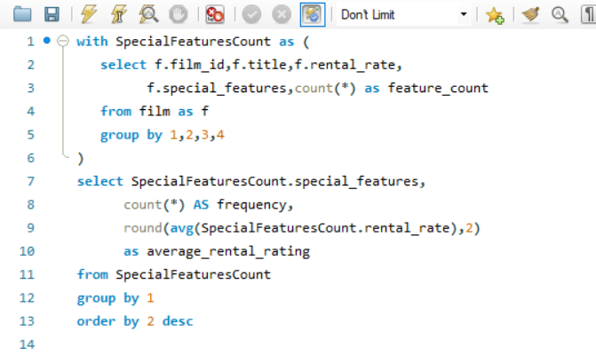**SQL-Query:**

**Visualization:**

**Insights:**

The problem statement inquiries about the most often used combinations of specific features in films and their correlation with film ratings. The provided chart illustrates that distinctive feature such as "Trailers," "Commentaries," and "Behind the Scenes" prominently favoured by viewers, showing a strong inclination towards engaging with bonus content. This observation underscores the significance of enriching the viewer experience beyond the film itself.

The high use of these specific features may signify that customers look for a more immersive and comprehensive cinematic experience. They value the opportunity to delve deeper into the film's production, gain insights from commentaries by directors or actors, and explore the creative processes behind the scenes. This not only enhances customer engagement but also fosters a deeper connection with the film.

For rental stores, this insight suggests a valuable opportunity. By offering films equipped with these popular specific features, rental stores can potentially boost customer satisfaction, fostering a more loyal customer base. Moreover, this approach can contribute to repeat business, as satisfied customers are more likely to return for future rentals. For using this insight effectively, rental stores can curate their film selection to include titles with high-demand specific features, aligning with customer preferences and the quest for an enhanced viewing experience. This strategic approach can result in a win-win scenario, satisfying customers while driving business growth and customer loyalty.

**Power-Bi Problem Statements:**

**Problem Statement:** 1) How does the sales revenue vary by month?

**Visualization:**

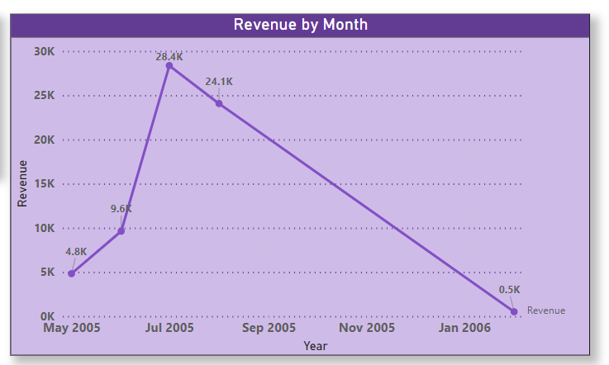

**Insights:**This line chart meticulously maps out the trajectory of sales revenue, offering a comprehensive understanding of financial trends over time. In the year 2005, a distinct upward trend in revenue is clear, peaking in July. This peak corresponds to the month with the highest number of films rented, suggesting a strong correlation between film rentals and revenue. This observation underscores the critical role that customer engagement and film selection play in driving revenue.

However, the next month’s reveal notable fluctuations, with a continuous downward trend from September 2005 to January 2006. These fluctuations may show a potential seasonality effect on film rentals, with a dip in customer activity during this period. It is crucial for the rental store to investigate the underlying factors contributing to these revenue variations and develop strategies to counteract the seasonality impact. The insights gained from the chart underscore the need for a nuanced approach to revenue management. The rental store should focus on finding areas of improvement and working to replicate the successful strategies implemented in July 2005. By tailoring inventory, marketing, and customer engagement efforts to the unique demands of different months, the rental store can stabilize its revenue streams, ensuring financial health and long-term success.

In summary, this analysis highlights the dynamic nature of sales revenue and underscores the seasonal impact on film rentals and the need for data-driven decision-making to enhance revenue performance throughout the year.

**Problem Statement:**

**2) Calculate Active or Inactive customers. And give details of those customers?**

**Visualization:**

**Insights:**

The pie chart presents a clear division of customer status, with a substantial 97% stands for active customers and a noticeable 2.5% falling into the inactive category. This distribution underscores the importance of customer retention and re-engagement strategies. While the majority stays active, the presence of inactive customers is a significant opportunity for improvement. And a table chart along with it shows details of Active/Inactive customers.

To effectively tackle the issue of inactive customers, it is imperative to employ targeted strategies based on data-driven insights. Analysing the above table, which supplies details about these inactive customers, can unveil valuable information about their preferences, past interactions, and reasons for inactivity. This data-driven approach can inform personalized campaigns and special discount offers aimed at rekindling their engagement.

Incorporating data-backed initiatives to re-engage inactive customers can be a pivotal step in perfecting customer retention and, by extension, overall revenue. It offers an avenue to tap into an untapped market segment and convert previously inactive customers into active and loyal patrons. This strategy aligns with the project's goal of enhancing customer satisfaction and store profitability, thereby strengthening the rental store's competitive position in the movie rental market.

**Problem Statement:**

3)Which customer segments generate the highest sales?

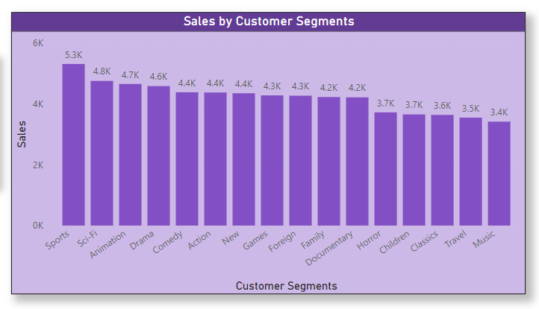**Visualization:**

**Insights:**

In the absence of predefined customer segments such as age or income in the dataset, I have used film categories as surrogate customer segments to gauge their impact on sales. The resulting chart effectively visualizes the contribution of each film category to total sales.

Remarkably, the chart portrays the "Sport" segment as the dominant revenue generator, significantly outpacing all other categories, followed by “Sc-fi,” “Animation” & “Drama,” while "Music" appears as the lowest contributor. This insight emphasizes the critical nature of focusing marketing efforts and strategies on these top-performing segments to both support and enhance revenue growth. The chart also underscores the need to employ data-driven strategies to harness the potential of these high-performing segments. It is imperative for rental stores to analyse and understand the customer preferences within each category, tailoring their offerings and promotional efforts accordingly.

Moreover, this data-driven insight highlights that investments in the first four to five customer segments are most likely to yield the highest returns. These segments should be the primary focus areas for future growth and expansion. By distributing resources strategically and perfecting the marketing mix for these top-performing segments, rental stores can further solidify their revenue streams and secure a competitive edge in the movie rental industry.

**Problem Statement:**

4)What is the distribution of films by rental duration?

**Visualization:**

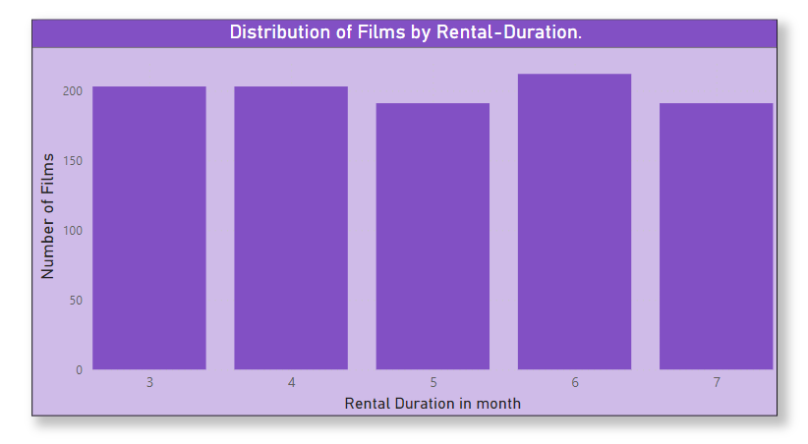

**Insights:**The chart offers a concise and insightful overview of the distribution of films by rental duration. It becomes clear that rental durations falling within the third (march)–seventh (July) range are the most prevalent among viewers. This distribution mirrors the typical viewing habits of customers, where they opt for rentals that cater to their short to medium-term entertainment needs.

The data also highlights a noteworthy pattern - the 6th month appears as the peak month for viewers. This signifies a significant spike in rentals during this period, aligning with a specific season or customer behaviour pattern. Understanding this peak month presents an opportunity for rental stores to tailor their marketing efforts, special promotions, and film selections to capitalize on this surge in customer engagement.

This chart contributes to a deeper comprehension of customer preferences in terms of rental duration. By acknowledging these patterns, rental businesses can curate their film collections and marketing strategies to cater to the predominant demand for films within the third (march)–seventh (July) month duration, enhancing customer satisfaction and rental revenue. The insights gained from this chart can be instrumental in perfecting inventory management and boosting rental store profitability.

**Problem Statement:**

5) How does inventory vary by film rating

**Visualization:** 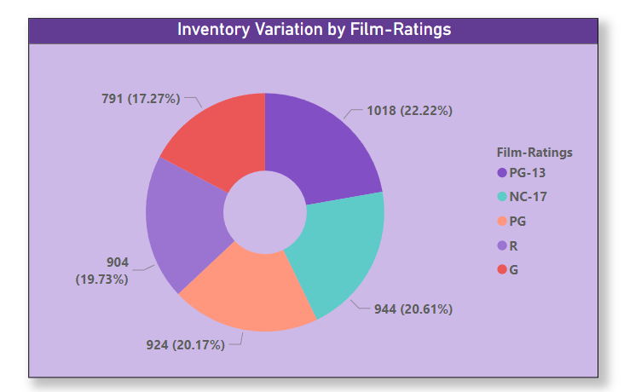

**Insights:**The column chart artfully portrays the intricate relationship between film inventory and viewer preferences. The rental store's inventory reflects customer choices, with a significant abundance of films rated as PG-13 (Parent-Guided) and NC-17 (no one under seventeen admitted). This allocation of inventory harmonizes with the broader demand for these specific rating categories, underlining the importance of aligning offerings with customer preferences. Conversely, the data points to a relative scarcity of inventory for G-rated films. This insight is valuable, as it can guide inventory management decisions and content acquisition strategies. It underscores the potential opportunity for rental stores to expand their selection of G-rated (general audience) films to cater to families and viewers with young children, tapping into a demographic that may underserved. The interplay between film inventory and viewer preferences has profound implications for rental store operations. By perfecting the inventory based on rating categories, rental businesses can enhance customer engagement and drive revenue growth. It is essential for rental stores to recognize these nuances in customer preferences and strategically manage their inventory to meet diverse demands.

In summary, the insights gained from this chart supply a strategic compass for rental stores, by responding to customer preferences and making data-driven decisions, rental stores can strengthen their position in the competitive movie rental industry and deliver a tailored experience to a broader audience.

**Problem Statement:**

6) Give Breakdown of film category by inventory?

**Visualization:** 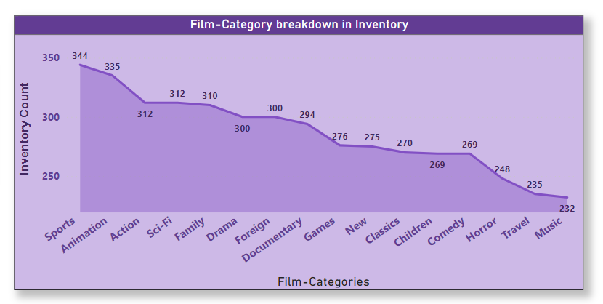

**Insights:**

This bar chart presented gives an all-encompassing view of the distribution of film categories within the inventory. Notably, "Sport" and "Animation" films appear as the leading categories, underscoring their prominence in the inventory. Conversely, "Travel" and "Music" categories occupy the latter positions, showing a lesser presence. This breakdown of film categories is a testament to the balanced inventory management strategies employed by the rental store. This balance is essential as it ensures that the rental store can effectively meet the diverse entertainment needs of its customers. Additionally, it aligns with the project's aim of enhancing customer satisfaction.

The chart is a showcase of diversity in film genres, offering the flexibility to adapt to the ever-evolving demands of viewers. By keeping a wide range of genres, the rental store can ensure the availability of customer-favourite categories. Furthermore, it serves as a strategic guide for perfecting content selection, offering data-driven insights that can influence content acquisition decisions.

The insights derived from this chart illuminate the rental store's commitment to supplying a well-rounded and customer-centric inventory. This approach is instrumental in meeting the varied tastes and preferences of viewers, contributing to overall customer satisfaction and revenue growth. It reinforces the store's position as a versatile and customer-oriented player in the competitive movie rental market.

**Problem Statement:**

7) What is distribution of staff by employment duration?

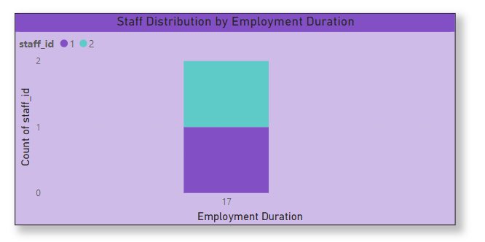**Visualization:**

**Insights:**

The column chart serves as a visual representation of the distribution of staff by their employment duration, shedding light on a specific aspect of the rental store's workforce. However, a notable aspect is that in the dataset, there are only two staff members, and their calculated employment duration appears to be the same at 17 years.

This unique observation signifies that the rental store is currently running with a small staff base. It also shows that the calculation method for employment duration may require further refinement to accurately reflect the staff's actual tenure. Given the importance of staff to the store's operations, this insight underscores the need for expanding the staff members' roster. Optimal staffing levels are pivotal in ensuring the efficient and seamless functioning of the store, from customer service to inventory management and overall store operations.

This data supplies a foundational perspective on the store's staff composition, but further data refinement and staffing augmentation may be essential to meet operational requirements and enhance customer service. By scaling the staff roster, the rental store can strategically perfect its workforce, contributing to smoother operations and customer satisfaction, which aligns with the project's goals of improving store performance and customer experience.

**Problem Statement:**

8)How does store performance vary by location?

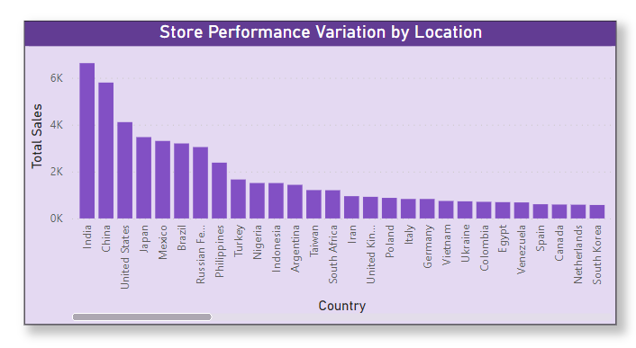**Visualization:**

**Insights:**

The analysis of store performance by location offers valuable insights into the dynamics of different stores within the rental business. The chart highlights that stores in India and China are consistently top performers, showing strong customer demand and operational efficiency in these regions. This observation is crucial for rental store owners, as it allows them to focus on replicating the successful practices from these stores and potentially expanding their presence in high-performing region. Conversely, the chart also highlights the variability in store performance, with underperforming stores in other locations. This insight enables rental store management to find areas that need improvement. By pinpointing these underperforming stores, they can distribute resources and implement targeted strategies to enhance their operations, boost customer satisfaction, and increase revenue. It offers a roadmap for addressing specific challenges that may be limiting the success of these stores.

The diversity in store performance highlighted in the chart underscores the complexity of the rental store industry and the importance of tailoring strategies to each store's unique context. By understanding the factors contributing to the success of stores in distinct locations, rental store owners can make informed decisions to uplift overall performance. It is a step toward a more efficient and customer-focused business model that can adapt to the varying demands and preferences of customers across different regions.

**Problem Statement:**

9) What is the average rental duration by staff member?

**Visualization**

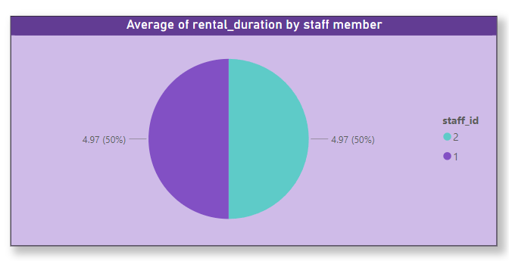

**Insights:**

The pie chart supplies a visual representation of the average rental duration attributed to each staff member, shedding light on a specific aspect of their performance. However, a distinctive characteristic of this analysis is that the dataset includes only two staff members, each of them contributing equally to the rental duration, with a share of approximately 4.9% each.

This unique observation underscores the limited scope of staff members in the dataset. While it may be indicative of the small sample size or dataset constraints, it raises questions about the scalability of the staff workforce and whether it aligns with the operational needs of the rental store.

For the rental store to enhance its service levels and meet customer demands effectively, it may be necessary to consider the addition of more staff members. This approach can perfect service quality, rental transactions, and inventory management, aligning with the project's goals of improving store performance and customer satisfaction.

This data highlights the staff's shared contribution to the average rental duration, underlining the potential for expanding the staff roster to better meet operational requirements and improve the customer experience. By scaling the staff team, the rental store can address operational challenges and drive greater efficiency in its daily operations, enhancing customer satisfaction and overall store performance.

**Problem Statement:**

10) What is the distribution of customers across different cities?

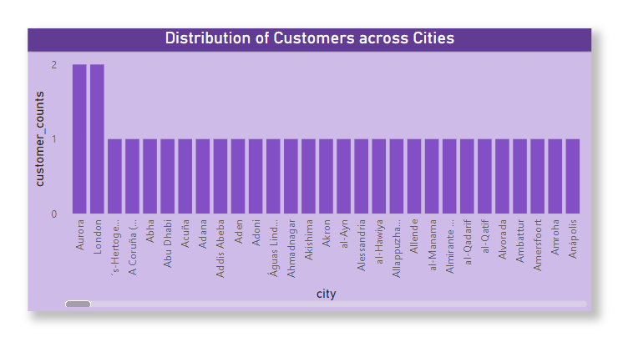**Visualization:**

**Insights:**

The column chart vividly illustrates the distribution of customers across various cities, offering valuable insights into the geographic reach of the rental store's customer base. Notably, City “Aurora” and “London” appear as the cities with the highest concentration of customers, signifying their robust engagement with the rental store. In contrast, other cities represented by only a single customer, suggesting an untapped potential for expansion in these locations.

This distribution of customers across cities serves as a strategic guide for the rental store. It shows the need for targeted efforts to attract more customers in cities where representation is less. By offering rental discounts, conducting marketing campaigns, and diversifying the film selection to cater to the unique preferences of customers in these cities, the rental store can unlock growth opportunities.

The insights derived from this column chart offer a roadmap for the rental store to refine its customer acquisition and retention strategies. By recognizing the unique characteristics and needs of customers in different cities, the store can strengthen its presence and build a more diversified customer base, contributing to long-term success in the competitive movie rental market.

**Problem Statement:**

11)How does the rental revenue vary by country?

**

**Insights:**

The column chart effectively visualizes the nuances in rental revenue across different countries, presenting a dynamic economic landscape within the movie rental industry. Notably, Country India takes the lead in revenue generation, followed closely by the United States and China.

This distribution of revenue highlights regional disparities and unveils the areas with the greatest rental revenue potential. These insights are pivotal for guiding strategic decisions and focusing efforts on targeted market development. By recognizing the top countries by revenue, rental stores can leverage their success and use it as a stepping stone for further growth and expansion. The data presented in this chart underscores the importance of tailoring business strategies to specific regions, considering the unique customer preferences, market dynamics, and economic conditions in each country. It aligns perfectly with the project's aim of enhancing revenue and maximizing the rental store's performance in different global markets.

In summary, the insights gained from this chart not only supply a snapshot of rental revenue variations by country but also offer a strategic compass for rental businesses to explore untapped potentials in high-revenue countries and broaden their global footprint in the competitive movie rental market.

**Problem Statement:**

12)**Which locations have the highest and lowest customer ratings?**

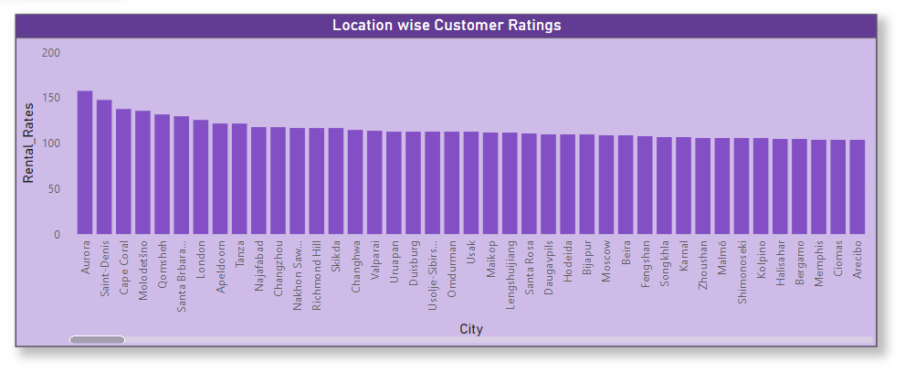**Visualization:**

**Insights:**

The column chart provides a visual representation of customer ratings across various locations, effectively distinguishing the top performers from those with lower customer ratings. Notably, "Aurora" appears as the top-rated location, signifying its success in delivering a prominent level of customer satisfaction. On the other end of the spectrum, "Fuzhou" lags, having the lowest customer ratings. This data serves as a foundation for knowledge-sharing and performance improvement initiatives, particularly in locations where customer ratings are highest. By sharing best practices and successful strategies from top locations, the rental store can encourage a culture of excellence and replicate success in other areas. This aligns with the project's aim of enhancing customer satisfaction and overall performance.

The chart also highlights the disparities in customer ratings, signifying an opportunity for collaboration. Locations with high ratings can partner with those with lower ratings to share insights and collectively work towards uplifting customer satisfaction levels. This collaborative approach fosters a sense of unity within the rental store's network, leading to overall performance improvement and enhanced customer experiences.

In summary, the insights derived from this chart offer a strategic roadmap for the rental store to enhance customer ratings and satisfaction across distinct locations. By learning from the successes of top-rated locations and fostering collaboration, the rental store can achieve a consistent and high standard of customer service, contributing to long-term success and growth in the competitive movie rental industry.

**Problem Statement:**

**13) What is the distribution of films by language?**

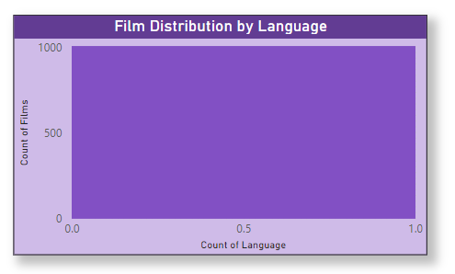**Visualization:**

**Insights:**

The column chart supplies a snapshot of film distribution by language, revealing a unique characteristic of the dataset only one language (English) option is available. This singular language distribution underscores the need for diversity and expansion in film language choices.

In the competitive movie rental market, offering a wider range of language options can be a strategic advantage. By adding more language choices for customers, rental stores can attract a more diverse customer base and generate added revenue. Multilingual film options cater to a broader audience, accommodating viewers who prefer content in different languages.

The insights from this chart emphasize the importance of catering to a global and multicultural customer base. It aligns with the project's aims of enhancing customer satisfaction and revenue growth by supplying a diverse range of film choices to meet the unique preferences of a wide range of customers.

In summary, while the dataset may currently offer only one language, the chart highlights the potential for expansion and diversification in language options. By doing so, rental stores can tap into new markets and foster customer loyalty by meeting their language preferences, contributing to long-term success in the movie rental industry.

**Problem Statement:**

**14) Which film categories have the highest rental rates?**

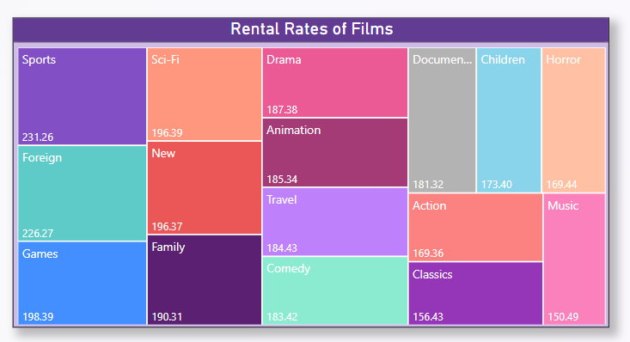**Visualization:**

**Insights:** The column chart provides a compelling visual representation of film categories with the highest rental rates, revealing that film categories such as "Sports" and "Foreign" take the lead in terms of Rental-Rates.

This data emphasizes the success of specific film categories and their contribution to the rental store's revenue. It also underscores an opportunity for growth by expanding the selection within these high-performing categories. By recognizing the popularity of "Sports" and "Foreign" films, the rental store can perfect its content strategy to maximize revenue potential.

The chart serves as a strategic guide for rental stores to harness the potential of these top-performing categories. By investing in content acquisition and marketing efforts that align with customer preferences for "Sports" and "Foreign" films, the rental store can further enhance customer engagement and satisfaction.

In summary, the insights derived from this chart open doors for perfecting content choice and marketing strategies. By capitalizing on the success of high-rental-rate categories, rental stores can elevate their revenue potential and meet the evolving demands of their customers, advancing the project's goals of improving revenue and customer satisfaction.

Top of Form**Problem Statement:**

15)**How does the average rental duration vary by film category?**

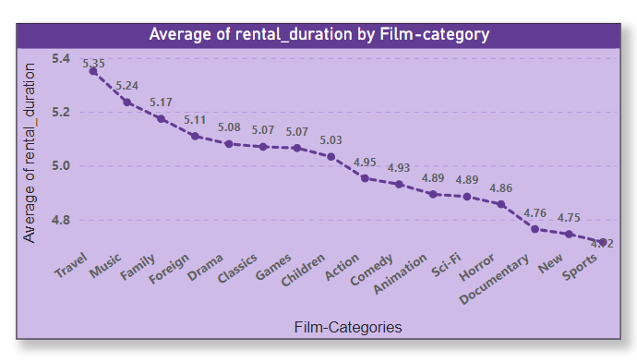**Visualization:**

**Insights:** The line chart offers a dynamic visualization of how the average rental duration fluctuates across different film categories, enabling us to distinguish notable variations. Particularly, the Film-category "Travel" stands out, highlighting the longest average rental duration, followed closely by "Music" and "Family" categories.

This data is pivotal for content curation and revenue optimization strategies. By understanding the diverse rental durations associated with different film categories, rental stores can fine-tune their content acquisition and inventory management. For instance, recognizing that "Travel" films tend to have longer rental durations suggests a potential for expanding the choice in this category to cater to viewers' preferences.

Additionally, the insights can guide pricing strategies. Films with longer rental durations could potentially price differently to maximize revenue, while those with shorter durations may receive help from strategic marketing efforts to boost rental numbers.

This chart equips rental stores with the knowledge needed to make informed decisions about content selection, pricing, and inventory management. By catering to the unique rental duration trends across various film categories, the rental store can perfect its content strategy, contributing to the project's goals of revenue growth and customer satisfaction.

**Problem Statement:**

**16) Variation of Rental Rate & Rental Duration by Country.**

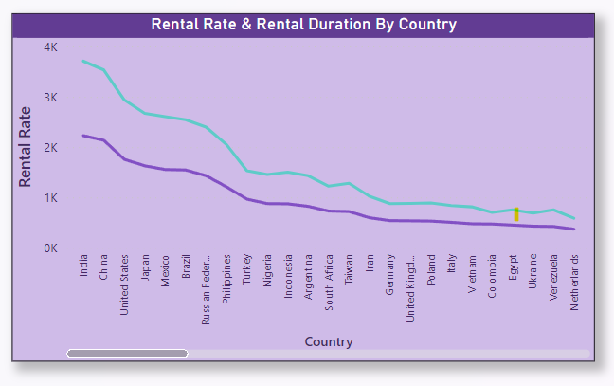**Visualization:**

**Insights:** The analysis of rental rates across different countries reveals a notable disparity, with India appearing at the top of the list, followed closely by China and the US. This variation suggests that pricing strategies may need to tailor to each country's economic landscape and consumer preferences. For instance, countries like India, with higher rental rates, may present opportunities for maximizing revenue, while nations with lower rates, such as Netherlands and Venezuela, may require more nuanced approaches to pricing to keep profitability while still being competitive. Furthermore, the differences in rental durations underscore the diverse viewing behaviours prevalent among audiences in various countries. Understanding these variations is crucial for content acquisition decisions and targeted marketing efforts. For example, countries with shorter rental durations may receive help from a focus on promoting new releases and encouraging frequent rentals, while those with longer rental durations may require a different content curation strategy to sustain engagement over extended periods. By using these insights, movie rental businesses can refine their pricing strategies and content offerings to better align with the preferences and behaviours of their target audiences in each country. This tailored approach can enhance customer satisfaction & improve rental market.

**Problem Statement:**

**17) Location wise Customer Rating.**

**Insights:** In this Chart, Aurora, and Saint Daniels shine as beacons of exceptional customer satisfaction, highlighting the effectiveness of existing strategies in catering to moviegoers' preferences. Exploring the specific aspects that contribute to their high ratings, whether it be exceptional customer service, diverse film selections, or engaging promotional campaigns, can unveil valuable insights for replicating success in other locations. This analysis could involve conducting customer surveys, gathering feedback from theatre staff, or studying demographic trends to tailor offerings to each city's unique needs.

Conversely, cities like Fuzhou, Bydgoszcz, and others with lower customer ratings present opportunities for targeted improvement efforts. Delving deeper into the factors driving dissatisfaction, such as subpar facilities, limited film choices, or inadequate amenities, can supply a roadmap for enhancing the overall cinema experience. Implementing measures such as facility renovations, expanding film genres, or introducing loyalty programs tailored to local preferences can help address these shortcomings and elevate satisfaction levels. By prioritizing customer feedback and aligning strategies with the distinct characteristics of each city, theatres can cultivate stronger connections with their audiences and foster enduring loyalty in the competitive entertainment landscape.

**Problem Statement:**

**18) Revenue Contribution by Film Rating.**

**Insights:**

Films rated PG and NC-17 stand out as primary revenue generators, indicating a robust demand for content spanning a broad age spectrum or delving into mature themes. This underscores a strategic opportunity for cinemas to capitalize on the popularity of these ratings through targeted marketing initiatives and curated film selections, driving sustained revenue growth and fostering a loyal audience base.

Conversely, G-rated films show a comparatively subdued revenue contribution, reflecting challenges in engaging audiences with family-friendly content. Finding underlying factors such as shifting demographic preferences or intensified competition from alternative entertainment avenues empowers cinemas to devise focused strategies aimed at bolstering attendance and revenue within this category. By implementing enhanced promotional campaigns and diversifying offerings to cater to a diverse audience palette, cinemas can invigorate revenue streams for G-rated films, ensuring a balanced portfolio tailored to meet the evolving demands of all audience segments, while cultivating a wholesome entertainment experience for patrons of all ages.

**Problem Statement:**

**19) Revenue & Inventory Distribution by film category.**

**Visualization:** 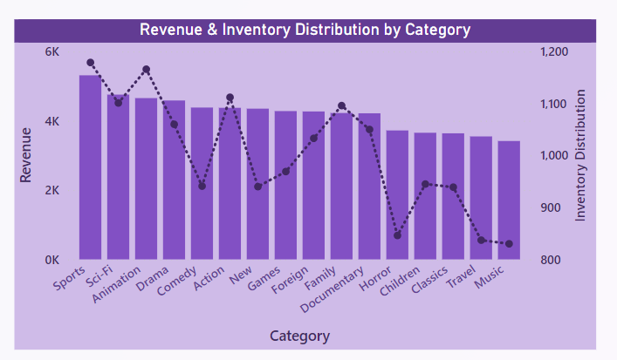

**Insights:**

In contrast to the lower revenue contributions from Travel and Music categories, the Sport and Sci-Fi genres appear as robust revenue drivers, reflecting a pronounced audience preference for action-packed narratives and futuristic themes. This underscores the imperative for cinemas to strategically position and promote films within these categories to maximize revenue potential. By capitalizing on the popularity of Sport and Sci-Fi genres through targeted marketing campaigns and curated content offerings, cinemas can bolster their bottom line and cultivate a loyal customer base.

Addressing the challenges posed by the comparatively lower revenue contributions from Travel and Music categories, cinemas can explore innovative approaches to enhance their appeal and profitability. Factors such as limited mainstream appeal or competition from alternative entertainment options may need tailored strategies to elevate the attractiveness of films within these genres. Implementing initiatives such as themed events, collaborations with local artists, or special screenings can revitalize interest in Travel and Music films, thereby diversifying revenue streams and enriching the cinematic experience for patrons.

**Problem Statement:**

**20) Rental Ratings Customer Wise.**

**Visualization:**

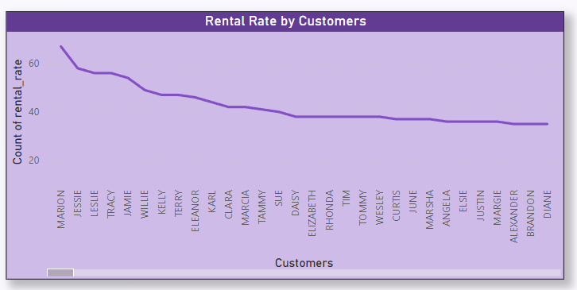

**Insights:**

Delving into rental rate variations by customers unveils nuanced patterns in consumer behaviour, shedding light on the intricate interplay between pricing strategies and customer preferences. This granular understanding empowers cinemas to refine their pricing models, striking a delicate balance between profitability and affordability. By using these insights, cinemas can implement tailored pricing strategies that resonate with diverse customer segments, fostering stronger brand loyalty and enhancing the overall customer experience. Moreover, continuous analysis of rental rate variations enables cinemas to stay agile in responding to shifting market dynamics, ensuring sustained relevance and competitiveness in the ever-evolving movie rental landscape.

**Problem Statement:**

**21) Rental Distribution by Films.**

**Visualization:** 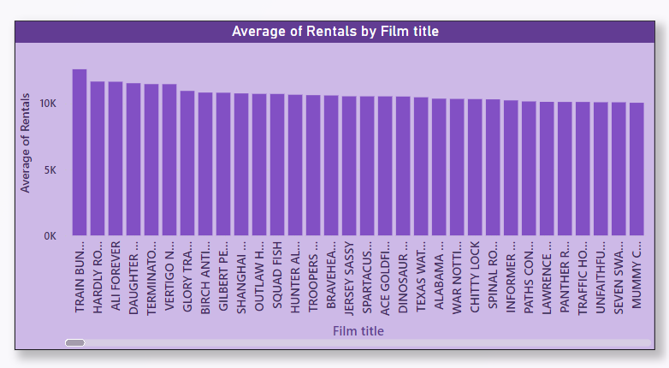

**Insights:**

As depicted in the chart, analysing rental distribution by films unveils critical insights into customer preferences and film popularity, enabling informed decisions for inventory management and content acquisition in the movie rental industry. By closely examining which films are most often rented, cinemas can strategically distribute resources to stock popular titles while minimizing excess inventory of less-demanded films. Additionally, understanding rental distribution patterns allows cinemas to tailor their marketing efforts and promotional campaigns to highlight top-performing titles, driving further rentals and revenue. Moreover, this analysis serves as a valuable tool for finding appearing trends and adjusting the film selection to meet evolving consumer preferences, enhancing customer satisfaction, and maximizing profitability in the competitive movie rental market.

**Problem Statement:**

**22) Distribution of films by Actors.**

**Visualization:**

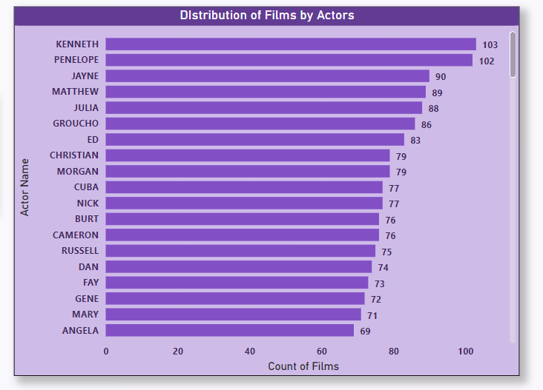

**Insights:**

As the chart shows, Kenneth and Penelope's significant contributions to film distribution underscore their versatility and widespread appeal among audiences. Their extensive presence across various movie titles suggests a strong ability to engage viewers and cater to diverse preferences, positioning them as valuable assets in the industry. In contrast, Judy and Emmily's lower film appearances may show areas for potential growth or strategic development. By exploring opportunities for increased casting or role diversity, they could expand their influence and broaden their reach within the entertainment landscape. Leveraging data-driven insights from actor-wise distribution of films enables stakeholders to make informed decisions about casting choices, talent management strategies, and content creation initiatives. It also supplies valuable feedback on audience preferences and trends, informing future production planning and resource allocation efforts. Additionally, understanding the dynamics of actor contributions to film distribution enhances industry professionals' ability to perfect casting decisions, foster talent development, and drive greater audience engagement and satisfaction.

**Problem Statement:**

**23) Actor Wise Variation of Rental Rate.**

**Visualization:**

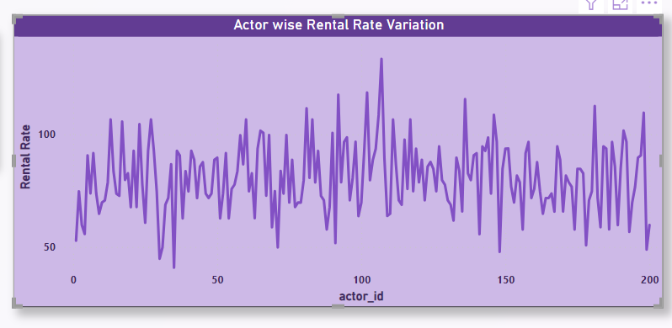

**Insights:**

The Actor-wise variation in rental rates indicates substantial disparities in audience preferences and perceived value among different actors, thereby guiding strategic casting decisions and content optimization efforts. This understanding of fluctuating rental rates associated with specific actors offers crucial insights into their marketability and influence on film consumption patterns, thereby enabling the implementation of targeted marketing strategies and talent management initiatives. By using these insights, stakeholders can effectively tailor their content offerings and promotional activities to align with audience preferences, enhancing viewer engagement and maximizing revenue potential. This comprehensive analysis underscores the importance of actor selection and highlights the pivotal role of data-driven decision-making in perfecting the performance and profitability of film productions within the entertainment industry.

**Problem Statement:**

**24) Actor wise Genre Preferences.**

**

**Insights:** The genre preference analysis depicted in the chart sheds light on the film genre preferences of actors, with a noticeable inclination towards PG-13 and PG-rated films. This preference shows a deliberate choice towards content that caters to a wider audience demographic, potentially reflecting actors' strategic career decisions aimed at maximizing audience reach and engagement. Additionally, the prominence of PG-13 and PG-rated films suggests actors' recognition of the commercial viability and widespread appeal of such content, aligning with their professional aspirations and the industry's prevailing trends. Conversely, the lower preference for G-rated films among actors may stem from a desire to explore roles with more complex narratives or thematic depth, catering to audiences seeking mature storytelling experiences.

Understanding actors' genre preferences provides valuable insights for filmmakers and casting directors, informing casting decisions and content creation strategies to align with actors' preferences and enhance project success. This analysis underscores the dynamic interplay between actor choices, audience preferences, and industry dynamics, emphasizing the importance of data-driven insights in shaping film production and talent management strategies.

**Problem Statement:**

**25) Revenue contribution by Actors.**

**Visualization:**

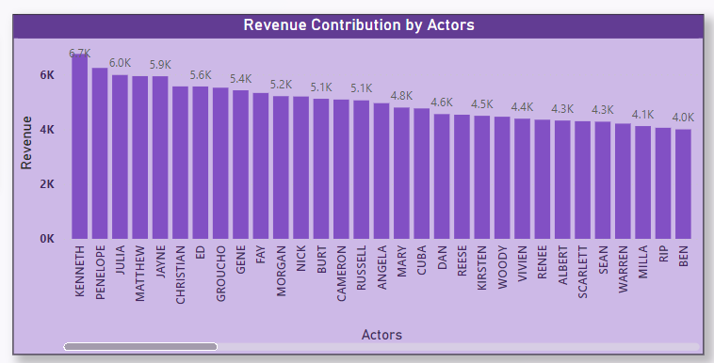

**Insights:**

This analysis of revenue contributions by actors offers valuable insights into the financial influence of individual actors within the film industry. By finding actors who significantly contribute to overall revenue, stakeholders can strategically distribute resources and prioritize talent acquisition to maximize profitability. This analysis underscores the importance of recognizing the marketability and box office appeal of specific actors in driving film success.

Understanding the varying revenue contributions among actors enables filmmakers to perfect casting decisions and tailor marketing strategies to capitalize on audience preferences. Moreover, it emphasizes the crucial role of data-driven insights in shaping casting choices and talent management practices to enhance project profitability and industry competitiveness.

**Power-Bi Dashboard:**

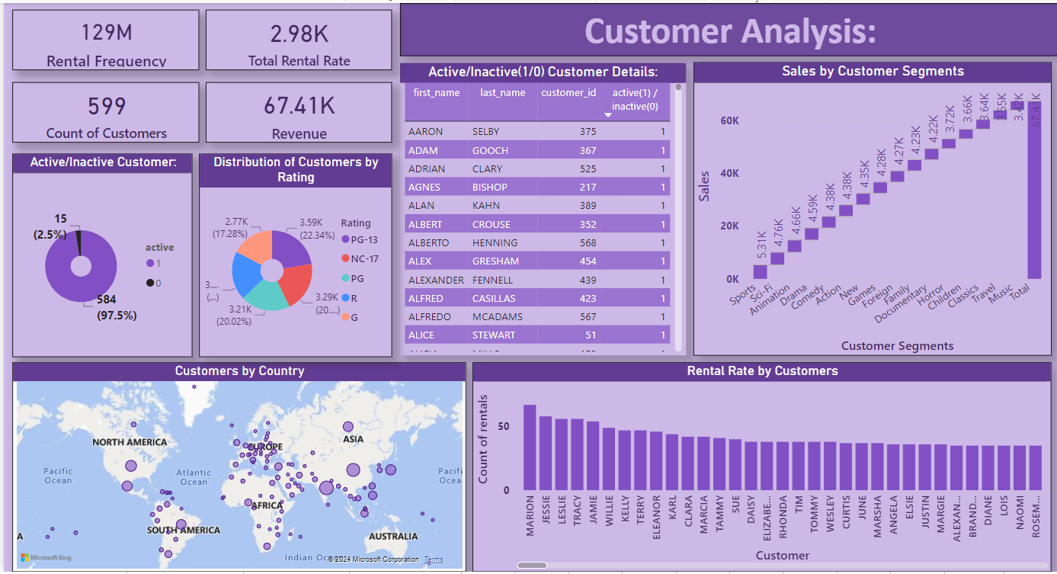**Customer Analysis:**

**Power-Bi Dashboard:**

**Rental Analysis:**

**Power-Bi Dashboard:**

**Revenue Analysis:**

**Power-Bi Dashboard:**

**Film Analysis:**

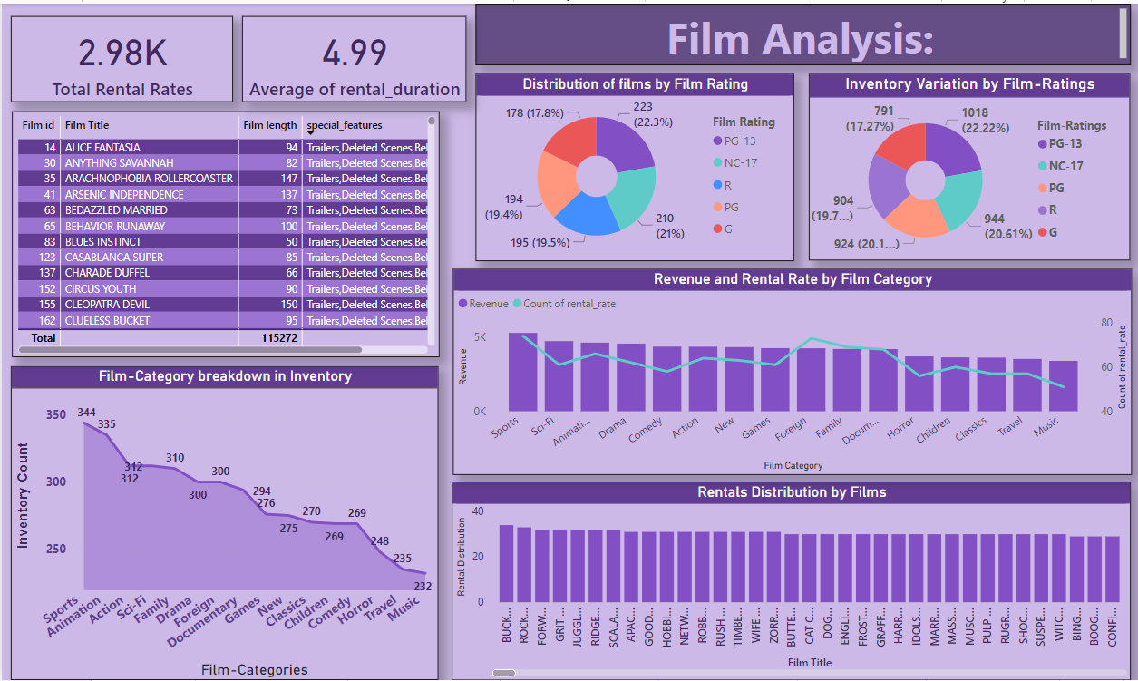

**Power-Bi Dashboard:**

**Location Analysis:**

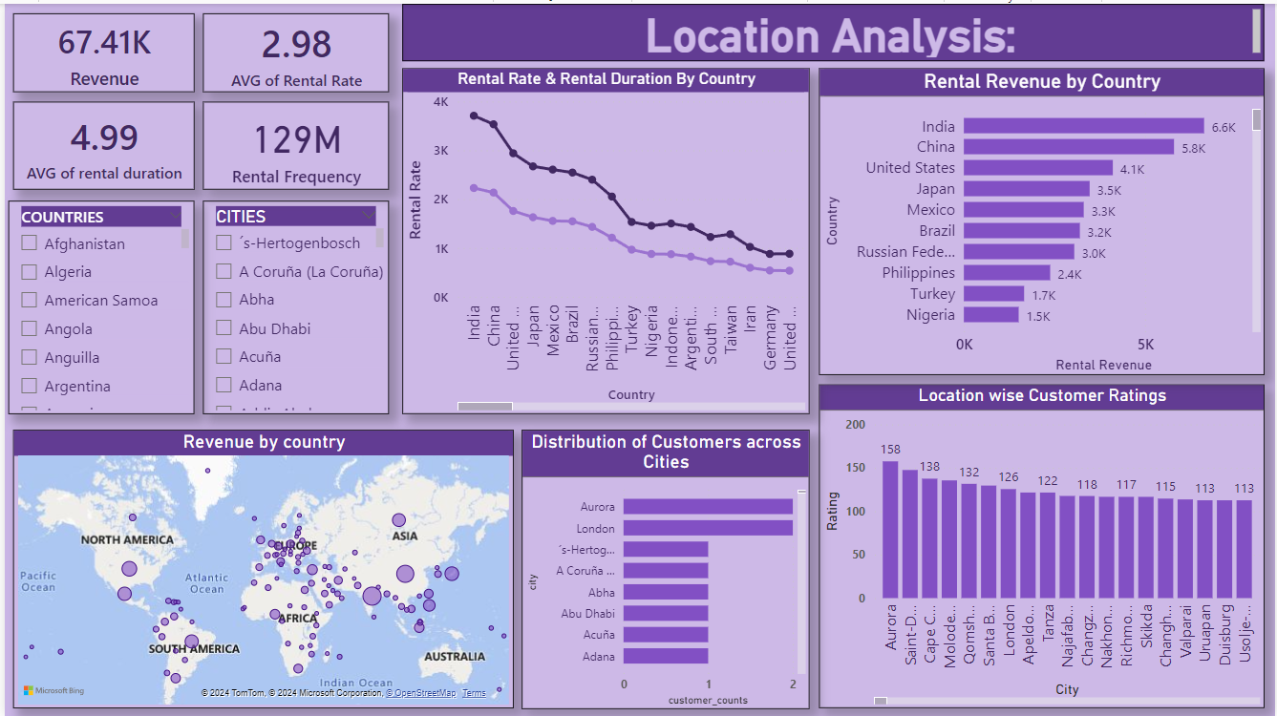

**Power-Bi Dashboard:**

**Actor Analysis:**

**Conclusion:**

The journey of this project has been a transformative one, encompassing multiple critical phases that culminated in a comprehensive analysis of the Sakila DVD Rental Store Database. From the very start of gathering data to the meticulous exploratory data analysis (EDA) and the later creation of insightful Power BI visualizations, every step has played a pivotal role in shaping the project's success.

The first phase of data acquisition was the bedrock upon which this project built. Retrieving the dataset from the Github repository marked the first step in our quest to gain valuable insights into the rental store business. The dataset, with its myriad tables and relationships, supplied a rich and complex foundation for analysis.

As I delved into the data, the exploratory data analysis (EDA) phase revealed compelling insights into customer behaviour, film inventory management, and store operations. SQL queries were instrumental in unearthing patterns, trends, and relationships within the dataset. Visualizations in Excel further illuminated these insights, transforming data into actionable recommendations.

The pivotal integration of Power BI into the project brought forth a dynamic tool for visual storytelling. Power BI dashboards enabled the creation of compelling visualizations that offered a deep dive into customer segmentation, sales trends, film performance, staff productivity, and store revenue. These visualizations bridged the gap between raw data and actionable insights.

The journey led us through a multitude of phases, each contributing to a more profound understanding of the rental store business. From finding the most-rented films to exploring the influence of film categories and customer behaviour, each analysis supplied a stepping stone towards the overarching project goals.

The conclusion of this project is a testament to the power of data-driven decision-making. It underscores the importance of informed choices in perfecting film inventory, enhancing customer satisfaction, improving staff performance, and streamlining store operations. The insights gained through this project offer a strategic roadmap for rental store owners, guiding them towards success in the competitive DVD rental market.

By harnessing the knowledge extracted from the Sakila DVD Rental Store Database, businesses can embark on a journey of continuous improvement, using data to drive success, profitability, and customer satisfaction.